**Name: Arnav Ranjan**

**Roll Number: R171218029**

**SAP ID: 500067731**

**Lab: 7**

**Creating pipeline using Blue Ocean Plugin**

**Steps**

**1.** Start Jenkins

**2.** Go to **Manage Jenkins** and click on **Manage Plugins**

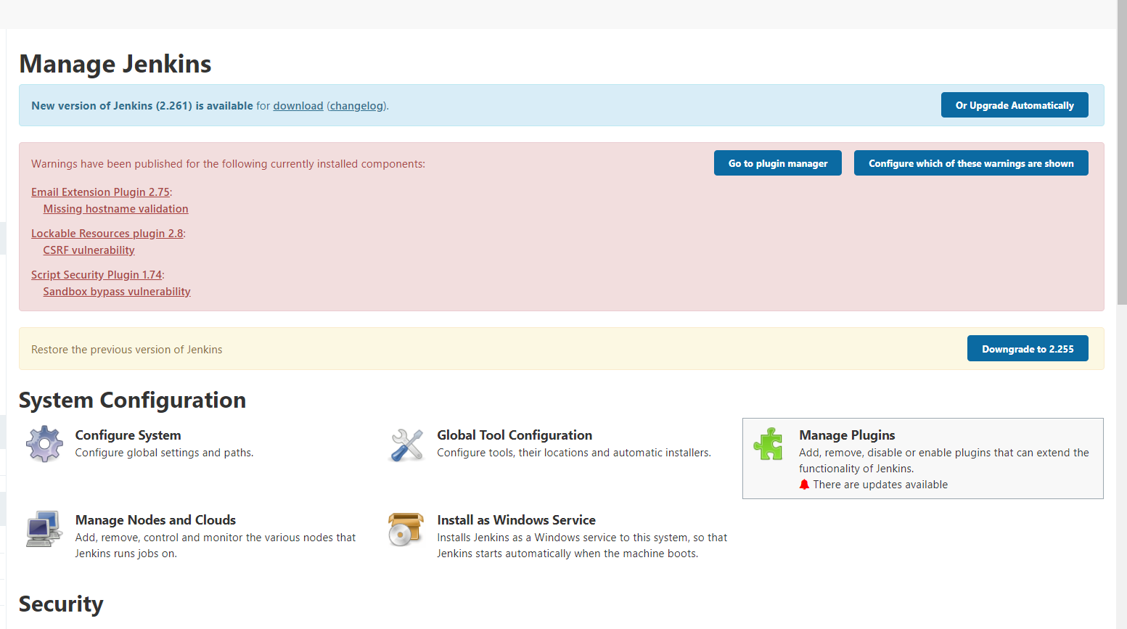

**3.** In available search **Blue Ocean**

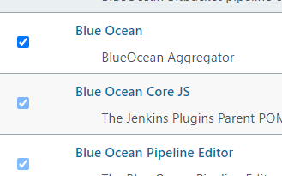

**4.** Download **Blue Ocean.**

**5.** Go to dashboard and start **Blue Ocean**.

**6.** Click on New Pipeline

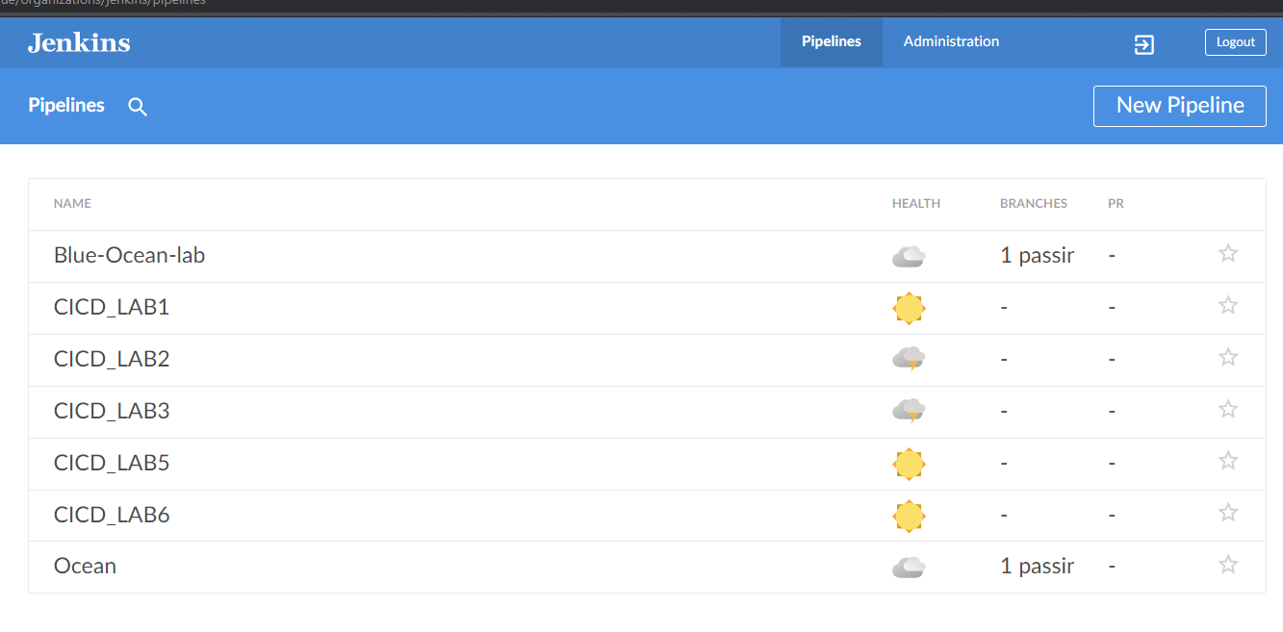

**7.** Now select your project location

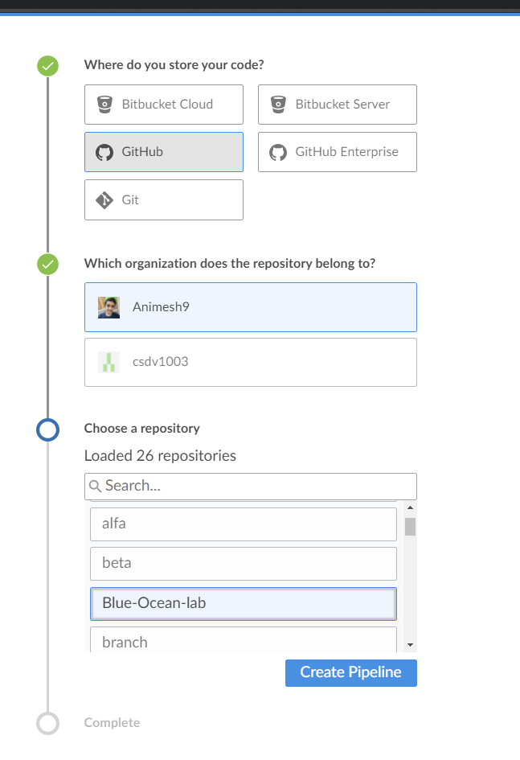

**8.** Click on **Create Pipeline**.

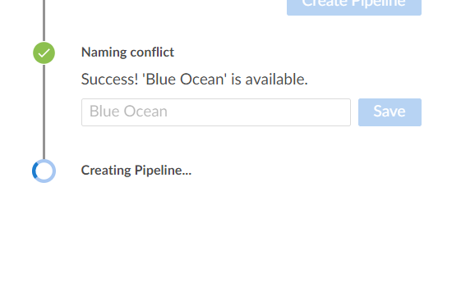

**9.** This will create a new pipeline.

